1. What is JOIN

<https://blog.codinghorror.com/a-visual-explanation-of-sql-joins/>

When selecting data between two table Join come into picture.

* INNER JOIN :

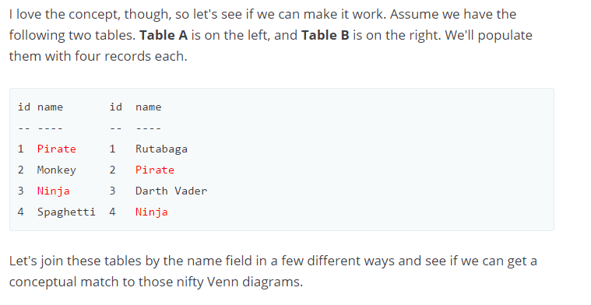

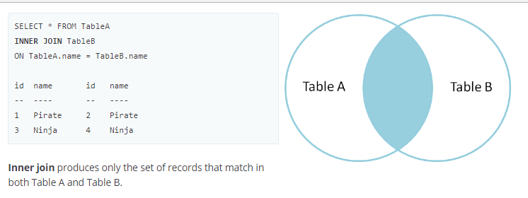

* FULL OUTER JOIN

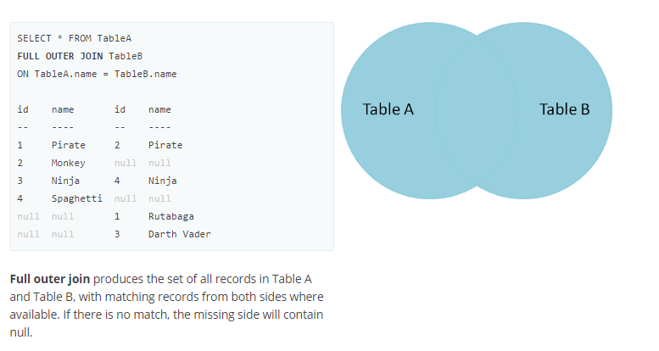

* LEFT OUTER JOIN

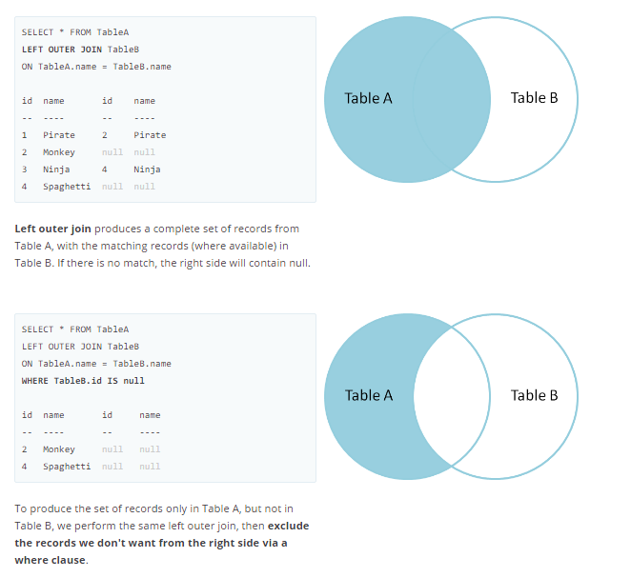

* CROSS JOIN

There's also a cartesian product or **cross join**, which as far as I can tell, can't be expressed as a Venn diagram:

SELECT * FROM TableA

**CROSS JOIN** TableB

This joins "everything to everything", resulting in 4 x 4 = 16 rows, far more than we had in the original sets. If you do the math, you can see why this is a *very* dangerous join to run against large tables.